

|  |  |  |  |  |  |  |  |  |
| --- | --- | --- | --- | --- | --- | --- | --- | --- |
| **Artifact Information** | | | | | | | | |
| **Artifact ID** | | **Artifact Title** | | | | | | |
| BST-001 | | Barcode Scanner Setup and Test Procedures | | | | | | |
| **Capstone Team** | | | | | **Revision** | | **Artifact Date** | |
| Capstone Team 27 - Granustem | | | | | 1.0 | | Mar 29, 2019 | |
| **Prepared by** | | | | | **Checked by** | | | |
| Jonathan Meldrum | | | | |  | | | |
| **Revision History** | | | | | | | | |
| **Revision #** | **Date** | | **Prepared by** | **Checked by** | | **Description** | | **Approved by** |
| 1.0 | Mar 29, 2019 | | Jonathan Meldrum |  | | Initial Version | | Reese Bastian |

1. Purpose

This artifact contains instructions for how to set up and test the barcode scanner.

2. Setup

We used the alacrity barcode scanner listed in Artifact [EBM-001] with its default settings. If you have modified the barcode scanner settings, you can reset its settings by following the procedure given on page 8 of the user manual (shown below).

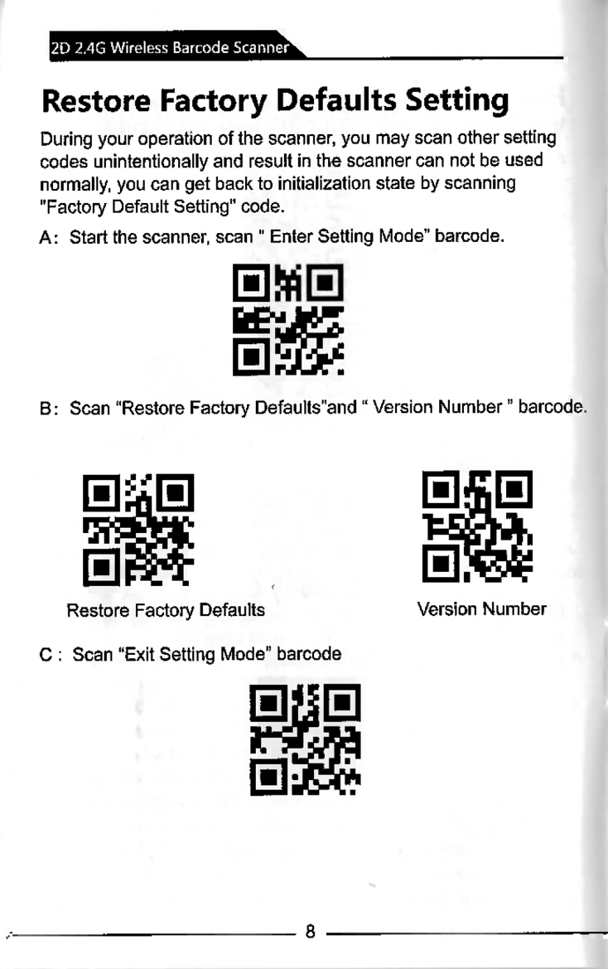

3. Test Procedure

1. Fully charge the barcode scanner.
   1. Use the USB type B cable. Plug the B-type end into the barcode scanner and the A-type and into a power source.
   2. Leave for 8 hours to ensure it is fully charged.
2. Connect the barcode scanner to a personal computer using the USB type B cable.
   1. Open a text editor.
   2. Scan the barcodes provided in the “Test Barcodes” section.
   3. Ensure that the output matches the results in the “Expected Output” section.
3. Follow the same procedure in step 2 but disconnect the USB type B cable from the computer and barcode scanner. Plug in the WiFi dongle into the computer instead.
4. Plug the WiFi dongle into a Raspberry Pi running the plant stalk measurement device software.
   1. Navigate to Settings -> Operator
   2. Scan the barcodes in order.
   3. Ensure that the Operator field changes to the text shown in the “Expected Output” section.

4. Test Barcodes

1.



2.



3.



4.

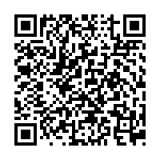

5.



5. Expected Output

1 MY

2 FATHER’S

3 Family

4 name being Pirrip, and my Christian name Philip…

988128